# Problem 3 – StockFlow

**Working with Remote Data**

For the solution of some of the following tasks, you will need to use an up-to-date version of the **local REST service** provided in the lesson’s resources archive. You can [read the documentation here](https://github.com/softuni-practice-server/softuni-practice-server).

**Environment Specifics**

Please be aware that every JS environment may **behave differently** when executing code. Certain things that work in the browser are not supported in **Node.js**, which is the environment used by **Judge**.

The following actions are **NOT** supported:

* **.forEach()** with **NodeList** (returned by **querySelector()** and **querySelectorAll()**)
* **.forEach()** with **HTMLCollection** (returned by **getElementsByClassName()** and **element.children**)
* using the **spread-operator** (**...**) to convert a **NodeList** into an array
* **append()** (use only **appendChild()**)
* **prepend()**
* **replaceWith()**
* **replaceAll()**
* **closest()**
* **replaceChildren()**

If you want to perform these operations, you may use **Array.from()** to first convert the collection into an array.

## Requirements

Write a JS program that can load, create, remove and edit a list of stock orders. You will be given an HTML template to which you must bind the needed functionality.

First, you need to install all dependencies using the npm install command

Then, you can start the front-end application with the npm start command

You also must start the ***server.js*** file in the ***server*** folder using the node server.js command in another console **(BOTH THE CLIENT AND THE SERVER MUST RUN AT THE SAME TIME)**.

At any point, you can open up another console and run npm test to test the **current state** of your application. It’s preferable for **all of your tests to pass locally** before you submit to the Judge platform, like this:

Картина, която съдържа текст, Шрифт, екранна снимка

Описанието е генерирано автоматично

## Endpoints

* [**http://localhost:3030/jsonstore/orders/**](http://localhost:3030/jsonstore/orders/)
* [**http://localhost:3030/jsonstore/orders/**](http://localhost:3030/jsonstore/orders/)**:id**

## Load All Orders

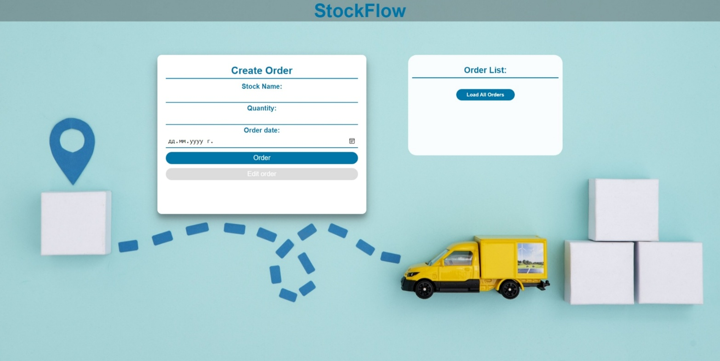

Clicking the **[Load All Orders]** button should send a **GET** request to the server to fetch **all stock orders** from your local database. You must add each task to the<div>with **id="list". [Edit order]** button should be deactivated.

Each order has the following **HTML** **structure**:

Картина, която съдържа текст, Шрифт, екранна снимка

Описанието е генерирано автоматично

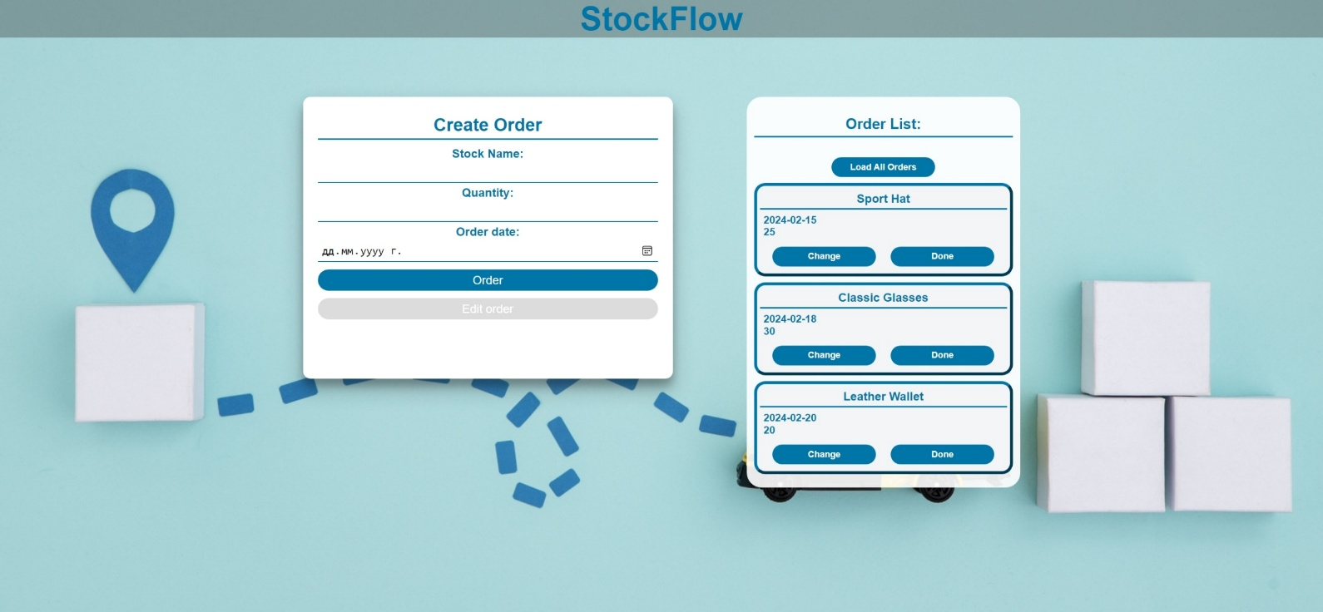

## Create an Order

Clicking the **[Order]** button should send a **POST** request to the server, creating a new stock order with the **stock** **name**, **quantity, and order date** from the input values. After a successful creation, you should send another **GET** request to fetch all the stock orders, including the **newly created** into the **Order List** column. You should also **clear all the input fields** after the creation!

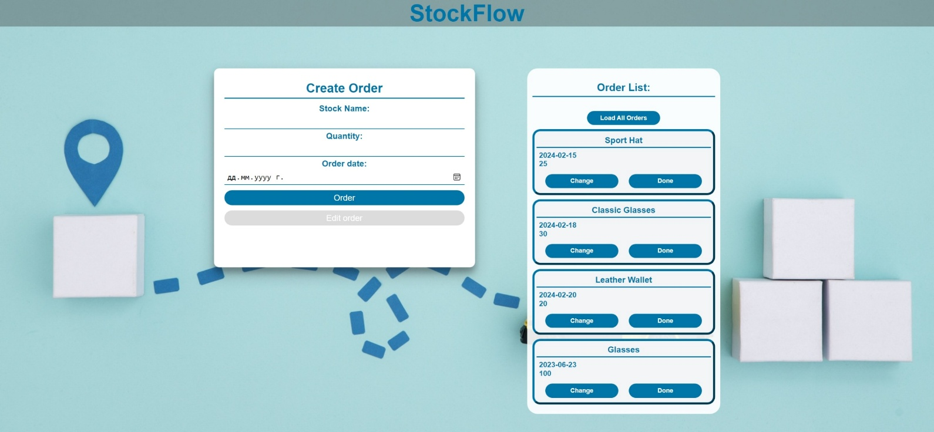

## Edit an Order

Clicking the **[Change]** button on a record should remove the record from the DOM structure and the information about the task should be populated into the input fields above. The **[Edit** **order]** button **in the** **form** should be activated and the **[Order]** one should be deactivated.

After clicking the [**Edit order]** button in the form, you should send a **PUT** request to the server to **modify the stock name, quantity and the date** of the changed order. After the successful request, you should **fetch the orders again** and see that the changes have been made. After that, the **[Edit** **order]** button should be deactivated and the **[Order]** one should be activated.

Картина, която съдържа текст, екранна снимка, Шрифт, номер

Описанието е генерирано автоматично

## Mark as Done

Clicking the **[Done]** button should send a **DELETE** request to the server and remove the order from your local database. After you've removed it successfully, **fetch** the items **again**.

## Submitting Your Solution

Select the content of your working folder (the given resources). Exclude the *node_modules* & *tests* folders. Archive the rest into a **ZIP** file and upload the archive to Judge.

Картина, която съдържа текст

Описанието е генерирано автоматично

Картина, която съдържа текст

Описанието е генерирано автоматично